Information letter №4
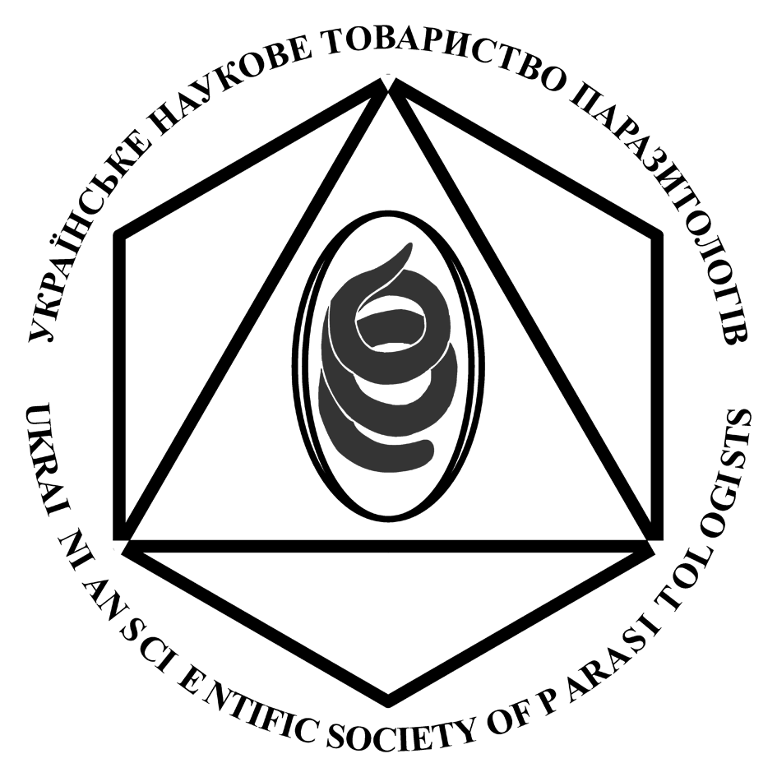 | XVI Conference of the Ukrainian Scientific Society of Parasitologists (USSP)  Lviv, September 18 – 21, 2017
Dear colleagues!
The Ukrainian Scientific Society of Parasitologists (USSP) and the Schmalhausen Institute of Zoology, National Academy of Sciences of Ukraine, in cooperation with the S. Z. Gzhytskyi Lviv National University of Veterinary Medicine and Biotechnologies invite you to take part in the XVI International Conference of the Ukrainian Scientific Society of Parasitologists (USSP) that will be held on September, 18–21, 2017 in Lviv city at the Lviv National University of Veterinary Medicine and Biotechnologies.
Registration of participants will be on September 18, 2017, from 10-00 to 14-00
in the lobby of the Faculty of Biology and Technology building of S. Z. Gzhytskyi Lviv National University of Veterinary Medicine and Biotechnologies; (Address: 50, Pekarska Street, Lviv).
For participants, who will come to Lviv later, it will be possible to register personally after the registration time during the Conference.
Registration fee is 60 Euros. It is to be paid on site during the registration. The fee includes expenses for the publication of abstracts, participants’ set of materials, coffee-breaks, mailing expenses, etc.
Forms of presentations
Plenary presentations – up to 30 minutes, including time for discussion; presentations at sections – up to 15 minutes, including time for discussion. Multimedia presentations will be accepted in MS Power Point format, stored on CD-disks or flash drives. Using personal computers for presentation is not allowed.
Posters should be oriented vertically, size not exceeding 90 x 120 cm.

Please, find the electronic version of the Programme of the Conference below in this Information Letter.

All participants who need Personal invitations to come to the Conference (for their Institutes or for the Ukrainian Custom), or Confirmations of the Registration fee payment, please, inform the Organizing committee personally as soon as possible.

ADDITIONAL INFORMATION:

Excursions to the picturesque sites around the Lviv city:
- Bus tour to Pidhoretsky, Zolochiv and Olesko Castles. Duration of the trip is about 8 hours; price per person (including lunch) 500 UAH (about € 18, or US$ 20). Please, register for the Bus tour at the Registration desk (on the 18th of September, 2017).
- Lviv City walking tour. Duration of the trip is about 2.5 hours; price per person about 100 UAH (€ 4, or US$ 4.5), depending on the number of participants. Please, register for the Bus tour at the Registration desk (on the 18th of September, 2017).
- Currency exchange rates: € 1 = 30.0 UAH (Ukrainian hryvna); US$ 1 = 26 UAH.

Transportation in the Lviv city
To get to the place of participants’ Registration (Address: 50, Pekarska Street, Lviv)
- from Railway Terminal, please use city tramway №1 to the tram-stop "Fredra street", or tramway №9 to the tram-stop "Zelena street"
- mini-vans № 15 to the stop "Shota Rustaveli street", or mini-vans № 29 to the stop "Chekhova street" (Military hospital)
- from Bus Terminal, please use trolley-bus № 5 to the stop "Shota Rustavelis street" (the last stop), or city-bus №3-А or mini-van №24 to the stop "Shota Rustavelis street".

To get to the Lviv city and the place of participants’ Registration from the Airport, please use city-bus №24 to the stop "Chekhova street" (Military hospital)

Contact information:
Postal Address: Organization Committee of the XVI Conference of USSP
I. I. Schmalhausen Institute of Zoology
Vul. B. Khmelnytskogo, 15
Kyiv, 01030, Ukraine

E-mail: untp@izan.kiev.ua;
taniak@izan.kiev.ua
Phone: (+38 044) 235–51–63; (+38 044) 234–73–21.
Fax: (+38 044) 234–15–69
Web-page: http://www.izan.kiev.ua/ussp/

USSP Board

Map with the place of the Conference
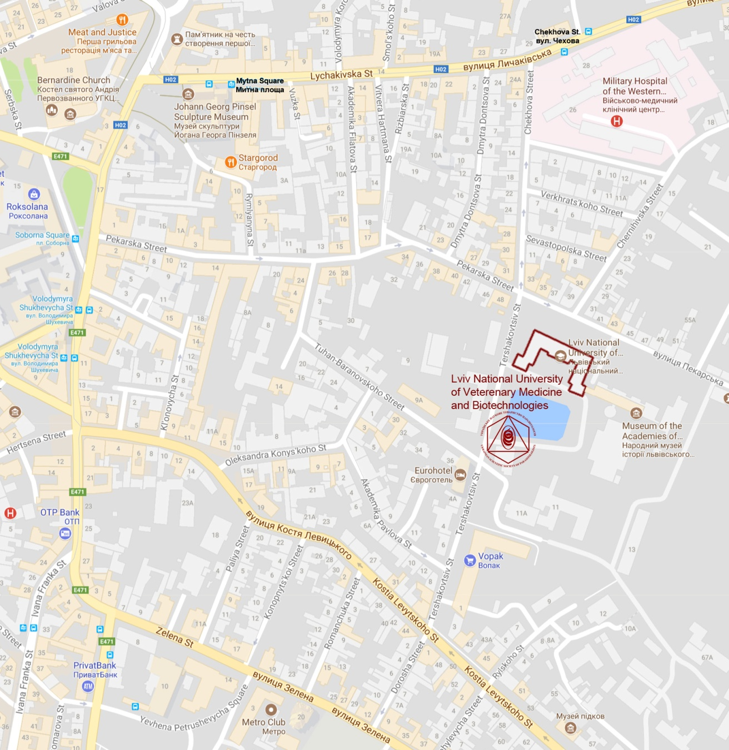

Programme of the Conference
Monday, September 18, 2017
13-00 – 14-00
Solemn Academy on the occasion of awarding
the DOCTOR HONORIS CAUSA title to
Professor Stanisław Winiarczyk
(University of Life Sciences in Lublin).
Plenary meeting
14-00 – 18-00
(in the lobby of the building of Faculty of Biology and Technology of the Lviv National University of Veterinary Medicine and Biotechnologies; address: 50 Pekarska Street, Lviv)
1. Opening of the Conference.
Opening address of Prof. І. А. Akimov, President of the USSP, Corresponding Member of the NAS of Ukraine.
Opening address of Prof. V. V. Stybel, Dr. Sci., Chancellor of the Lviv National University of Veterinary Medicine and Biotechnologies
- Congratulatory speeches.
Plenary reports
- Kharchenko V.O. Parasitology: Neglected Science.
- Berezovsky A.V. Application of combined chemotherapeutic agents to control parasitoses of productive animals.
- Ovcharenko M.O. Microparasites of invasive hydrobionts in European waters.
- Soroka N.M. Actual problems of Lyme disease.
16-00 – 16-20 – Coffee break (20 min.)
- Kornyushin V.V. Taxonomic structure of the superfamily Hymenolepidoidea Perrier, 1897: a working hypothesis.
- Prus M.P., Perehinyak N.S. Blood parasites of horses in Ukraine.
- Tolstoy V.A. Incidence of trichinosis in the territory of the Republic of Belarus in the dynamics of long-term observations.
- Yuryshynets V.I. Symbionts of aquatic animals as indicators of the ecological state.
- Nikolaenko S.M., Matiushkina K.O., Sagach O.S. Topical issues of monitoring of epidemiological situation on parasitic diseases in Ukraine.
- Huliaev D.P. "Parasites" in computers.
19-00 – Welcome dinner
(near the Assembly Hall of the Lviv National University
of Veterinary Medicine and Biotechnologies;
address: 50 Pekarska Street, Lviv
Faculty of Biology and Technology, 3rd floor)
Tuesday, September 19, 2017
Section meetings
(in the Main building of the Lviv National University of Veterinary Medicine and Biotechnologies;
address: 50 Pekarska Street, Lviv)

Section of General Parasitology (room № 7)
10-00 – 11-40
Moderators – Kornyushin V. V., Ovcharenko M. O.
- Akimov I.A., Nebogatkin I.V. Emergence and Re-emergence tick-borne diseases related to changes in tick.
- Akimov I.A., Zabludovskaya S.A., Badanin I.V. Morphological variability of mites of the subfamily Speleognathinae (Acariformes, Ereynetidae) related to hostal specificity.
- Leonovich S.A. Behavior of ixodid ticks (Ixodidae) in relation to their ontogenesis.
- Paulauskas A., Radzijevskaja J., Aleksandravičienė A. Prevalence of pathogens in Dermacentor reticulatus ticks in Baltic region and Central Europe.
- Radzijevskaja J., Matulaitytė V., Paulauskas A. Prevalence of tickborne pathogens in ticks collected from migratory birds in Lithuania.
- Nebogatkin I., Ranka R., Capligina V., Rodyna N., Shevchenko O., Berzina I., Akimov I. Ecological peculiarities of hard ticks in 2016 in Ukraine and their medical and veterinary importance.
- Sukhomlin K. B. Zinchenko O. P. Adaptations of blood-sucking black flies to feed on homoiothermal tetrapods.
11-40 – 12-00 - Coffee break (20 min.)
- Ovcharenko M.O. Cucumıspora dıkerogammarı – "demons" destroyer of European waters.
- Krasnovyd V., Vetešník L., Šimková A. The interspecies hybridization and its consequences on the richness and distribution of parasites.
- Nikolaev K.E. Transmission patterns of trematodes in coastal communities of the Subarctic seas.
- Kvach Y., Ondračková M., Kutsokon Y., Dzyziuk N. Non-native monogeneans on invasive pumpkinseed and Chinese sleeper in Ukraine.
- Sigareva D.D., Kovtun A.M., Boltovska O.V. Entomopathogenic nematodes as a component part of agricultural cenoses in Ukraine.
Lunch – 13-00 – 14-00

Section of General parasitology (room № 7)
14-00 – 18-00
Moderators – Kharchenko V. O., Scherbatyi A. R.
- Sarabeev V.L. Abundance, prevalence and aggregation of helminth parasites in the native and introduced range of Liza haematocheilus (Teleostei: Mugilidae): testing the enemy realise hypothesis
- Gordeev I. I., Sokolov S. G., Orlov A.M. Marcoparasites of the blue hake Antimora rostrata (Gadiformes:Moridae) in the northwestern Atlantic.
- Innal D., Tocan B. Review of the geographic distribution and host records of Ligula intestinalis (Cestoda) in Turkey.
- Kvach Y., Bryjová A., Sasal P., Winkler H.M. The taxonomic status of two cryptogonimid species (Digenea: Cryptogonimidae) from brackish water fish of the Black Sea.
- Innal D., Gülle I. New localities and host records for Lernaea cyprinacea (Copepoda: Lernaeidae) in west mediterranean region of Turkey.
- Greben O.B., Kornyushin V.V. The first record of cestode Wardium cirrosa (Krabbe, 1869) (Cyclophyllidea, Aploparaksidae) in Ukraine and some data on its life cycle.
- Syrota Ya.Yu., Greben O.B. Helminthes of the mallard (Anas platyrhynchos L.) in Ukrainian Polissya.
16-00 – 16-20 – Coffee break (20 min.)

16-20 –18-00 – Poster Session (room № 5)

Section of Veterinary parasitology (room № 6)
10-00 – 13-00
Moderators – Prus M. P., Fedets O. M., Soroka N.M.
- Presentation report of the "Brovafarma" company: Berezovsky A.V., Nagorna L.V. Improvement of the system of antiparasitic measures in ectoparasitoses of productive poultry.
- Galat M.V., Galat V.F. Effectiveness of diagnostics of toxoplasmosis in animals.
- Chernov V. N., Ushakov O. S. Heartworm in dogs: chemoprophylaxis and screening.
- Boyko O.O., Gevorgyan R.S., Bryhadyrenko V.V. Influence of cinnamaldehyde on the viability of nematode larvae of ruminants.
- Shyder E.I. Methods of using ivermectin in rabbits infested with psoroptosis.
- Korchan L.M. Anthelmintic efficiency of different ivermectin forms to control pulmonary protostrongylidosis of goats.
11-40 – 12-00 – Coffee break (20 min.)
- Soroka N.M., Stets O.V. Intestinal parasites of Furcifer pardalis.
- Kruchynenko O.V. Heavy metal content in the liver of cattle and pigs after agents of parasitic diseases damage.
- Kaplich V.M., Yakubovsky M.V., Bachur O.V. Associative parasitoses of wild ungulates in Belarus.
Lunch – 13-00 – 14-00
Section of Veterinary Parasitology (room № 6)
14-00 – 18-00
Moderators – Soroka N. M., Galat M. V., Wróblewski Z.
- Hurníková Z., P. Komorová, G. Chovancová. Trichinella pseudospiralis in wildlife of Slovakia.
- Miterpáková M., Víchová B., Čabanová V., Hurníková Z. New emerging canine parasites, Hepatozoon canis and Thelazia callipaeda in Slovakia.
- Víchová B., Miterpáková M., Koneval M., Blaňarová L., Hurníková Z.. Circulation of neglected intravascular pathogens in European red fox (Vulpes vulpes) population, Slovakia.
- Jarošová J., Antolová D., Halán M. Hymenolepis spp. in small rodents; the risk of zoonotic transmission of infection.
- Slivinska K., Karbowiak G., Werszko J., Szewczyk T., Wróblewski Z., Víchová B., Peťko B. Molecular detection of Theileria equi and Anaplasma phagocytophilum infections in horses in some regions of Ukraine.
- Chernous E.A. Elaboration of the PCR method of diagnostic of trichinellosis.
- Melnychuk V.V., Gugosyan Yu.A. Morphometric characteristics of Strongyloides westeri.

16-00 – 16-20 – Coffee break (20 min.)
16-20 – 18-00 – Poster session
(in the Main building of the Lviv National University of Veterinary Medicine and Biotechnologies;
address: 50 Pekarska Street, Lviv) (room № 5)
10-00 – 18-00 – Presentations of companies-sponsors
(hall near to the rooms № 6 and 7)

Wednesday, September 20, 2017
Section meetings
(in the Main building of the Lviv National University of Veterinary Medicine and Biotechnologies;
address: 50 Pekarska Street, Lviv)

Section of General and Medical parasitology (room № 7)
10-00 – 13-00
Moderators –Salamatin R. V., Tolstoj V. A., Sagach O.S.
- Stybel V.V., Danko M.M., Sobolta A.H., Golubtsova M.V. Features of the course of some zooanthroponoses in rural areas.
- Nikolaenko S.M., Matiushkina K.O., Sagach O.S. Topical issues of monitoring of epidemiological situation regarding parasitic diseases in Ukraine.
- Safonov R.V., Byalkovsky O.V., Brezetska O.I., Shelevitska L.V., Grytsiuta L.V. Epidemiological situation on parasitic diseases in the Rivne region in 2012–2016.
- Sagach O.S., Nikolaenko S.M., Matiushkina K.O. Current status of the system for carriers of human infectious and parasitic diseases in Ukraine.
- Matiushkina K.O., Nikolaenko S.M., Sagach O.S. Problem of Echinococcosis in Ukraine and principal directions of its prevention.
- Lisitsyna O. I., Kuzmina T.A., Spraker T.R., Kudlai O.S. New records of acanthocephalans from the California sea lions Zalophus californianus (Pinnipedia: Otariidae) in California, USA.
- Akiner M. M., Öztürk M., Demirci B., Bedir H. Increased risk of the mosquito borne parasitic and virutic diseases for the middle and eastern Blacksea region of Turkey related to the invasive mosquito species distribution.
11-40 – 12-00 - Coffee break (20 min.)
- Zaleśny G., Pyrka E., Hildebrand J., Kołodziej-Sobocińska M., Zalewski A. Genetic diversity of Isthmiophora melis occurring in American mink (Neovison vison) in Poland
- Čabanová V., Miterpáková M., Dzidová M., Stloukal E., Hurníková Z. Natural vectors of dirofilariosis in urban area of Bratislava capital city, Slovakia.
- Antolová D., Miterpáková M., Ondriska F., Gál V. Human cases of Dirofilaria repens infection in Slovakia recorded between 2007 and 2017.
- Kaczmarek A., Żarnowska-Prymek H., Rawska A., Jańczak D., Lewicki A., Wesołowska M., Cielecka D., Rożej-Bielicka W., Gołąb E., Sałamatin R. Genetic diversity of Blastocystis isolated from humans in Poland.

Lunch 13-00 – 14-00

Section of General and Veterinary parasitology (room № 7)
14-00 – 15-15
Moderators – Kharchenko V.O., Salamatin R. V., Kruchynenko O.V.
- Iakubchak O.N., Taran T.V. Histological changes of beef for sarcocystosis.
- Alieksieieva Ye.O., Yevstafieva V.А. Influence of the sheep ked infection on growth and development of young sheep.
- Dashchenko S.O. Clinical case of strongyloidosis in a dog.
- Pashkevich I.Yu. Clinics of the otodectosis in dogs and cats.
- Korzan A.I., Chirtzova S.V., Martynov S.S., Berezyuk R.I. Epidemiological situation on dirofilariosis on the territory of the Brest region of the Republic of Belarus.
15-15 – 15-35 - Coffee break (20 min.)
14-00 – 16-00 – Poster session (room № 5)
10-00 – 17-00 – Presentations of companies-sponsors
(hall near to the rooms № 6 and 7)
Plenary meeting
16-00 – 17-30
(in the Assembly Hall of the Lviv National University
of Veterinary Medicine and Biotechnologies;
address: 50 Pekarska Street, Lviv
Faculty of Biology and Technology, 3rd floor)
1. Discussion on the results of the Conference.
2. Discussion and acceptance of the Conference Resolution.
3. Report of the Presidium of the Ukrainian Scientific Society of Parasitologists on its work in 2014–2017 – Kharchenko V. O.
Closing ceremony

19-00 – Farewell banquet
(at the "SUPUTNYK" Rrestaurant
address: 116 Kniagyni Olgy Street, Lviv)

Thursday, September 21, 2017
10-00 – 18-00
Excursion day

Away meeting of UNTP Presidium

Departure
Poster session
(in the Main building of the Lviv National University of Veterinary Medicine and Biotechnologies; address: 50 Pekarska Street, Lviv) (room № 5)
1. Zhytova E. P., Kornyushyn V. V. Specificity of parthenogenetic stages of trematodes to their intermediate host – mollusks.
2. Korol E.N. The role of amber snails (Gastropoda, Succineidae) in the life cycles of trematodes on the territory of Ukraine.
3. Murvanidze L., Lomidze Ts., Nikolaishvili K., Arabuli L., Davitaia K., Asatiani K. Plerocercoids larvae of Ligula intestinalis (Cestoda) and metacercariae of Diplostomum spathaceum (Trematoda) in Carassius gibelio (Bloch, 1782) from Madatapa lake (South Georgia).
4. Podvyaznaya I.M. Morpho-functional features of the germinal mass in the redia of Bunocotyle progenetica.
5. Dmitrieva I., Kuzmin Y. Investigation of helminth communities of marsh frog, Pelophylax ridibundus, (Amphibia: Anura) from urbanised territories in Kyiv Oblast, Ukraine.
6. Mardosaitė-Busaitienė D., Radzijevskaja J., Paulauskas A., Balčiauskas L. Genetic diversity of Bartonella species detected in small rodents in Lithuania.
7. Paulauskas A., Klepeckienė K., Ražanskė I., Radzijevskaja J. Tick-borne pathogens from cervids in Lithuania.
8. Sidorenko M., Radzievskaja J., Paulauskas A. Investigation of TBEV in different species of ticks in Lithuania.
9. Kubiak K., Sielawa H., Tylkowska A., Dzika E., Dziekońska-Rynko J. Prevalence of tick-borne pathogens in questing Dermacentor reticulatus (Fabr. 1794) ticks in North-Eastern Poland.
10. Dmitryjuk M., Szczotko M., Michalski M.M. Identification of Anaplasma phagocytophilum in Ixodes ricinus tiks removed from city agglomeration dogs.
11. Karbowiak G., Slivinska K., Stanko M. The blood sucking arthropods of small rodents in Chornobyl exclusion zone—preliminary study.
12. Sałamatin R., Rydzanicz M., Nowak R., Kuśmirek W., Cielecka D., Sobczyk-Kopcioł A., Żarnowska-Prymek H., Płoski R., Młocicki D. Mitochondrial genomics of the tapeworm Hymenolepis diminuta: comparative characteristics of the human and laboratory strains.
13. Karczewski G., Sałamatin R., Konieczna-Sałamatin, J., Gołąb E. Comparison of the three commercial Toxoplasma gondii IgG antibody test kits.
14. Iashvili N., Murusidze M., Kokaia N., Zakaraia Ts., Khvedeliani M. Zoonotic helminthiasis in Georgia.
15. Yakovlev Ye., Shkvyria M. Prospects of studies of influence of radionuclides (¹³⁷Сs, ⁹⁰Sr, ²⁴¹Am) accumulating in "Helminthes – Carnivover" system under conditions of radioactive post-catastrophe.
16. Jarošová J., Antolová D., Rosoľanka R., Szilágyová M., Šimeková K. Alveolar echinococcosis in Slovakia.
17. Kuzmina T., Spraker T., Lyons E. Parasites of Northern Fur Seals (Callorhinus ursinus L.) as indicators of ecological alteration in the ecosystem of the Bering Sea.
18. Kuzmina T.A., Spraker T.R., Lyons E.T., Lisitsyna O.I. Gastrointestinal parasites in California sea lions (Zalophus californianus): biodiversity and age-related alterations in parasite community.
19. Kuzmina T.A., Zvegintsova N.S., Zharkikh T.L. Gastrointestinal parasite community in a new population of the Przewalski’s horse (Equus ferus przewalskii) in the Orenburg state reserve, Russia.
20. Slivinska K., Klich D., Yasynetska N. Comprehensive parasitologic survey of the wild Przewalski`s and domestic horses in the Chornobyl exclusion zone, Ukraine during 2015-2017 years.
21. Slivinska K., Jastrzębska E., Jaworski Z., Wróblewski Z. The parasitic fauna of the Polish koniks and their impact on the breeding: health management practices.
22. Vinarska A.V. Efficacy of the ivermectin against the parasitoses of horses.
23. Akimov I.A., Didyk Yu.M. Occurence of Trichinella (Nematoda, Trichinellidae) amongst wild animals in Ukraine.
24. Shabdarbayeva G. S., Akhmetova G. D., Usmangaliyeva S. S., Khussainov D.M. Distribution and diagnostics of trichomonosis of large cattle in the Almaty region.
25. Nechypurenko О.O., Troian H.D., Hrushkovska І.V., Dreval D.V., Sobko І.O. Differential diagnostics of histomonosis in turkeys.
26. Zhemerdey O.V., Soroka N.M. Spread of Varroa jacobsoni and Nosema apis in bees.

